**messageformats**

**Message Formats**

**A Data Communication Historical Series**

**By Bob Pollard**

**Message Formats:**

Message formats changed along with the technological advances in the available equipment (devices) and computer systems. Figure 1 represents a typical message format used in the 1950’s and early 60’s.

The advent of ‘powerful’ and flexible computer systems in the 1960’s and 70’s created a very flexible and comprehensive message routing and control capability, which resulted in very complex message formats. Figure 2 is a typical example of message formats used in computer systems prior to the Internet environment.

**Click illustrations to enlarge; use the back arrow to return**

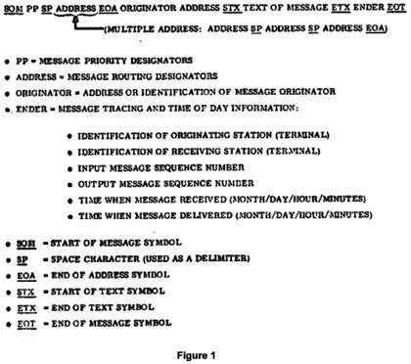

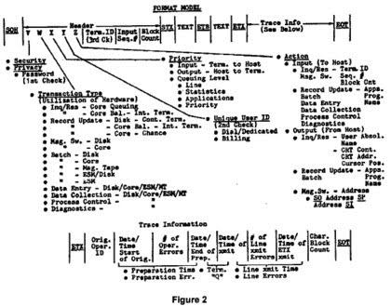

**Basic Web page access:**

Even with the flexibility that was provided with the invention and implementation of the World Wide Web (WWW), usually referred to as the ‘Internet’, which really took off in the 1990’s, not much has changed when it comes to terminal selection. The terminals (Personal Computers) of today still have to be selected before transmitting and receiving can be accomplished.

When a user (client) wants to access a Web page residing on a distant Web server a basic sequence of events or actions will occur. This sequence of events would be initiated and then continue to follow some basic steps, as listed below. A review of Figure 3 may be useful for a pictorial view of these events as they occur. The ‘hash’ marks, - - - - -, represent machines (computers) and the software systems that are variable in number and location.

First, assuming the Web connection is through a local Internet Service Provider (ISP), a connection to the ISP must be accomplished. Using a dial-up line a connection is made using the normal telephone system.

The user has an URL (Uniform Resource Locator) for a Web page, which is entered in the browser address line. Lets say the URL is http://Autodin.net/alp/mhd.htm and after it is typed in the ‘go’ button or ‘enter’ is pressed. This Web site being accessed contains historical information on the AUTODIN communications system and the above URL will bring up the page containing information on a moving head disk.

The user’s browser connects to the AUTODIN Web server, through the example path illustrated in Figure 3 and the requested page will be displayed on the user’s screen (monitor).

The basic steps that occurred behind the scenes to cause this to happen would be as follows:

• The user’s browser broke the URL into three parts:

1. The protocol ("http")

2. The server name (www.autodin.net)

3. The file name (web-server.htm)

• The user’s browser communicates with a ‘name server’, through the ISP, in order to

translate the web server name ‘www.autodin.net’ into an IP (Internet Protocol) address, which it uses to connect to the web server machine.

A unique 32-bit IP Address (Internet Protocol Address) is assigned to every computer connected directly to the Internet and this unique identifying number would be a grouping of numbers (up to 12) such as, 192.1.26.2.

• The user’s browser then connects to the web server at that IP address on port 80.

• Following the HTTP (Hypertext Transfer Protocol) protocol, the user’s browser sends a request to the web server, asking for the file "http://autodin.net/alp/mhd.htm.

• The web server then sends the HTML text for the Web page to the user’s browser. Cookies may also be sent from web server to the user’s browser in the header for the requested page.

• The user’s browser reads the HTML tags and formats the page onto the screen.

The page displayed on the screen is now available to be saved or copied for whatever purpose the user may have in mind, although not all web sites allow the page to be directly copied. The displayed page may have links to other pages and, if clicked, will cause the previous step-by-step process to be accomplished for that requested page. A ‘link’ is usually identified by an underline (_____), italics, a different color, named buttons or a list of pages available within the web server. When the mouse arrow is pointed to the link the pointer usually changes to the pointing hand.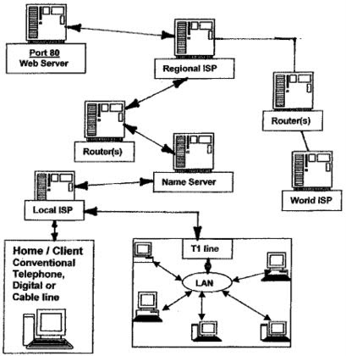

**Figure 3**